**The Anti-Math**

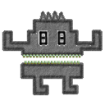

**Pablo Bernal Alarcón**

Youtube link for reference: https://youtu.be/h8rWLLspYpk

**Game Overview:**

The Anti-Math is a game targeted to kids. The purpose of the game is for the user to practice the 4 basic math operations (Addition, Subtraction, Multiplication, Division), by providing a fun and challenging method to do so. It was my PG1 project.

**Platform:**

Unity3D

**Plot:**

The Anti-Math is a monster that is known for chasing people who are bad at math. One day, the Anti-Math finds you and wants to eat you. You as the main character must escape from him by using your math skills to get away from him.

**Objective and Gameplay:**

The player must get to his house before the monster catches up to him. How does he do it? The player is thrown basic math questions by the game, which vary in difficulty depending on how the player chooses. The player then, based upon the question the game gives (say something like “5 + 5 = “), must input the correct answer. If the player gets the question right (by answering “5”, of course) he´ll get one step closer to his house. If he fails, however, he´ll either not move or take a step back. The game ends whenever the player reaches his house or gets caught by the monster.

**Features**

**A**

* Practice the four basic math operations in a fun way
* Two game modes: Get to the house, which challenges the player to reach a certain spot before getting caught by the monster, and Math-rathon, an endless game mode that gets progressively harder as the player answers more questions correctly.
* Unique, cute, cartoonish style. I´d like to make it feel like if it was all hand-drawn with crayons.
* Animations and sound effects. Every character is going to have their respective animations and sound effects, the best for whatever they represent.
* **Feedback.** This is a game targeted for kids, so a good feedback is key. At all times, they´ll know what´s happening, what they´re doing and how they´re doing it.
* Android tablets. The game will be released for android devices.

**B**

* IOS and phones release. The game will be released for Apple devices.
* PC release. The game will be tweaked and released for pc on steam.
* Website. To reach out to more people, the game can have a website.
* Game expansion. If the player is good enough, or even by default, binary operations and logic gates can be added to the topics the player can choose.

**C**

* Customizations. The player will be able to choose between being a boy or a girl.
* Some things can be altered, such as the player´s shirt color or the monster´s color.
* In-game currency. This currency is gained game after game, and it may unlock new things such as new colors for the player and monster and even new house models for the player.
* Be you! A feature that consists of the player taking a picture and adding that picture as the character´s face.

**Below are some screenshots of the original game:**

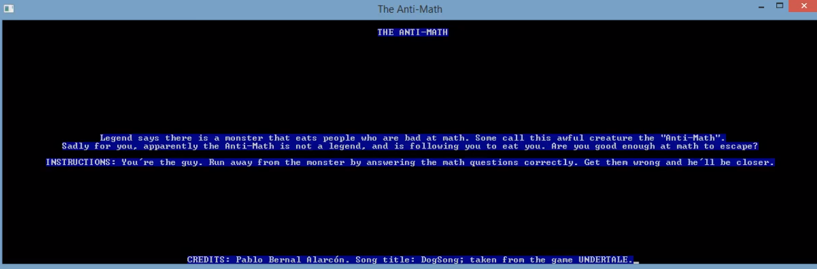

“THE ANTI-MATH --- Legend says there is a monster that eats people who are bad at math. Some call this awful creature the “Anti-Math”. Sadly, for you, apparently the Anti-Math is not a legend, and is following you to eat you. Are you good enough at math to escape? --- INSTRUCTIONS: You´re the guy. Run away from the monster by answering the math questions correctly. Get them wrong and he´ll get closer”.

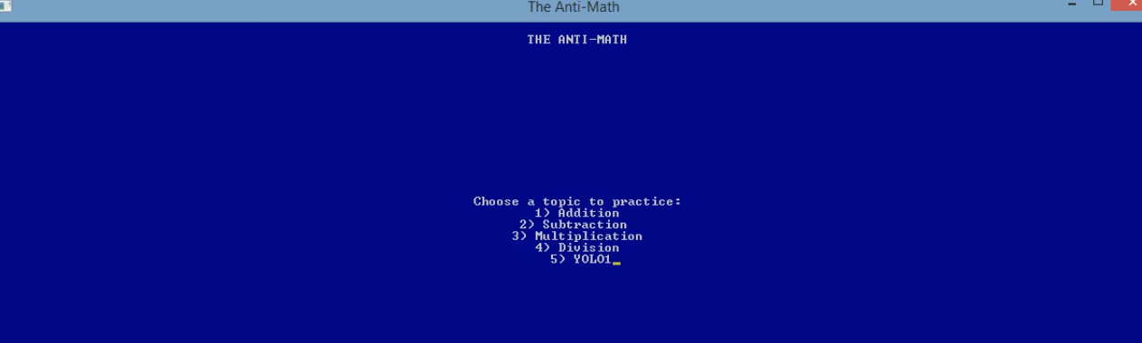

“Choose a topic to practice: 1) Addition, 2) Subtraction, 3) Multiplication, 4) Division, 5) Yolo!”

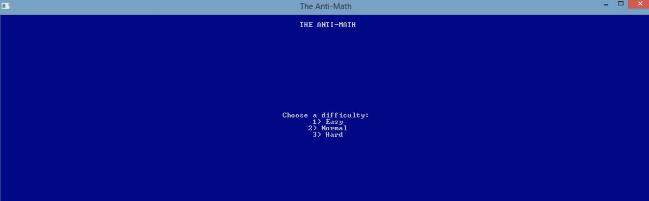

“Choose a difficulty: 1) Easy, 2) Normal, 3) Hard”

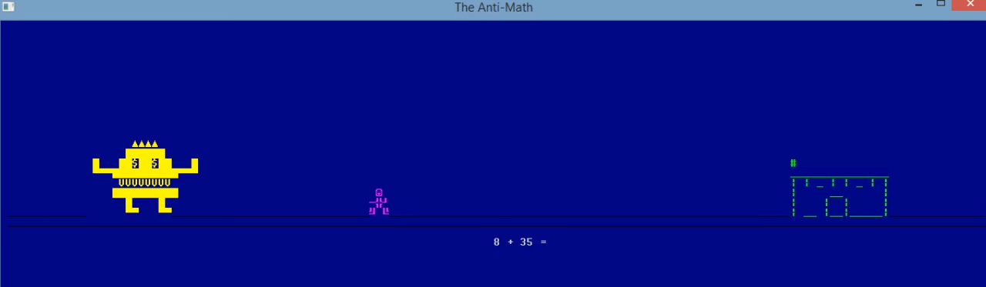

In-game footage

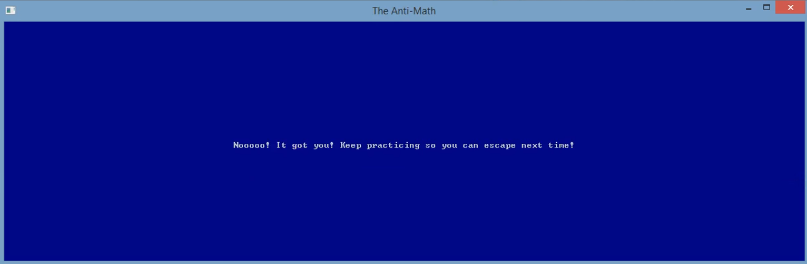

Losing Scene: “Nooooo! It got you! Keep practicing so you can escape next time!”

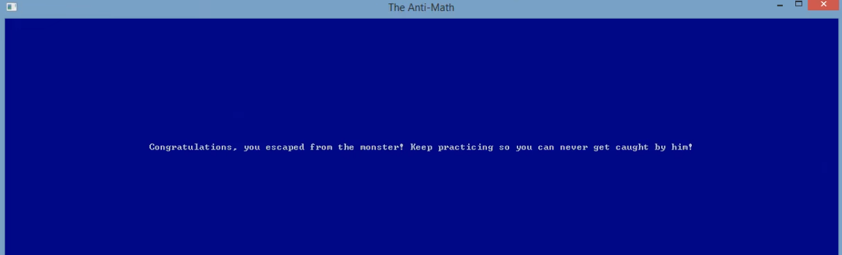

Winning scene: “Congratulations, you escaped from the monster! Keep practicing so you can never get caught by him!”